Q.1
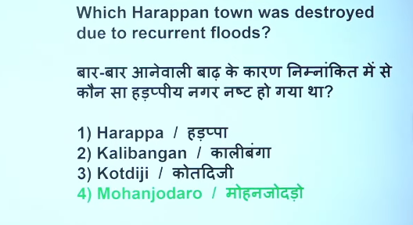
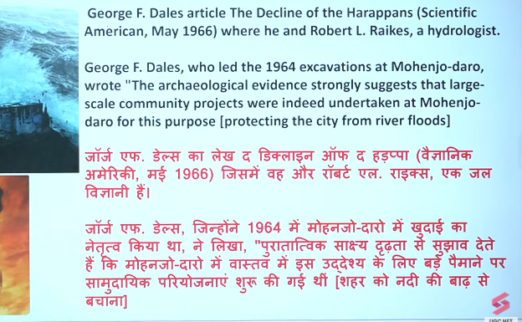

Q.2
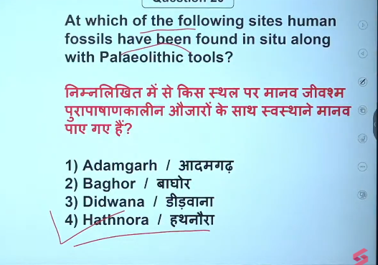

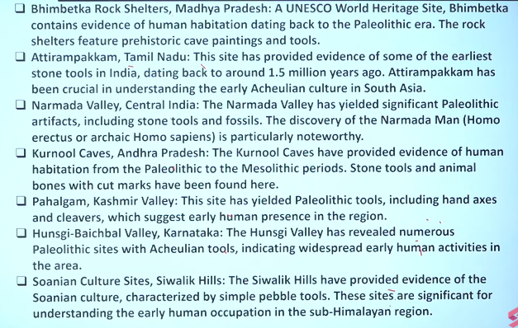
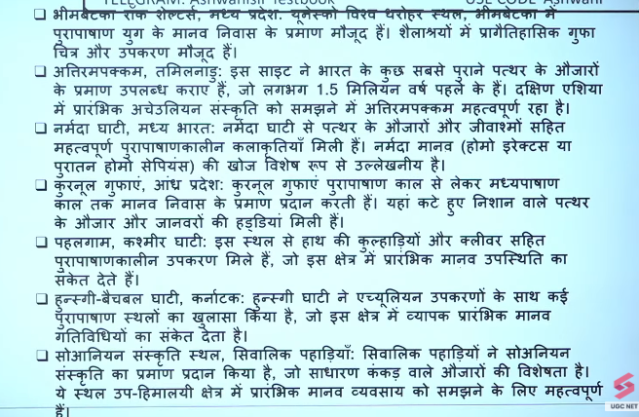
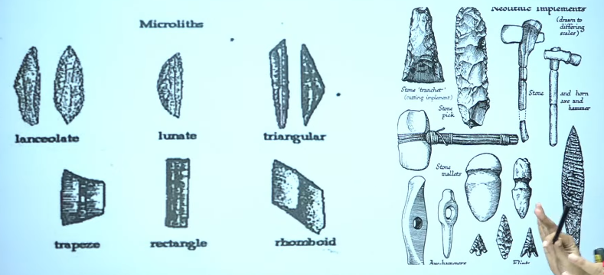
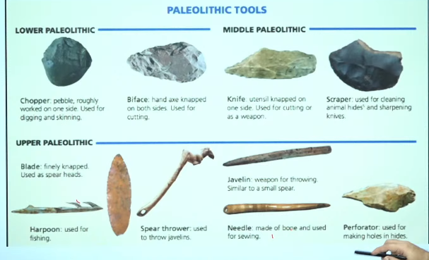

Q.3
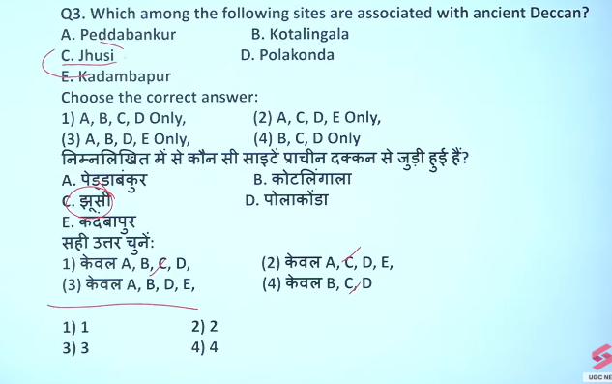

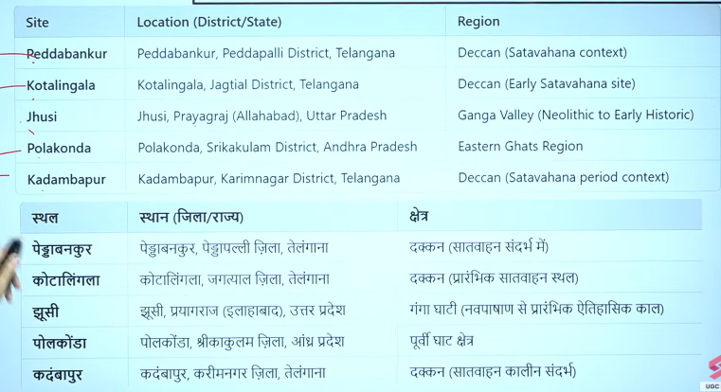

Q.4
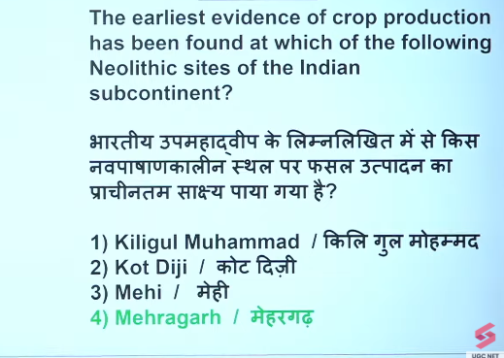

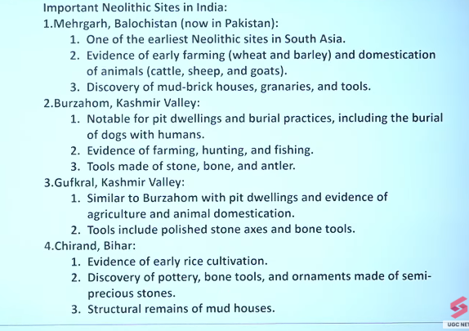
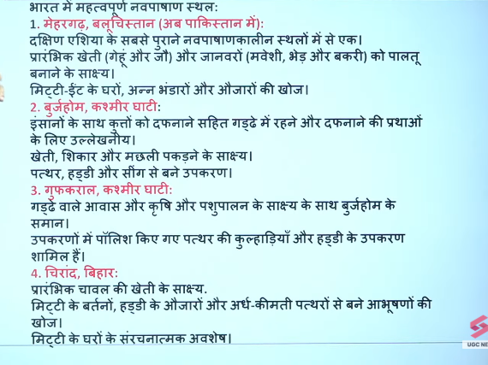

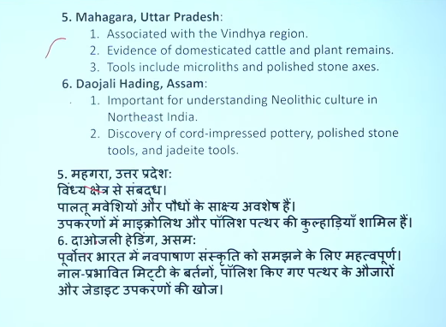

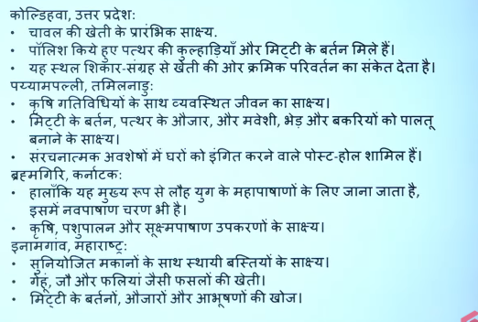
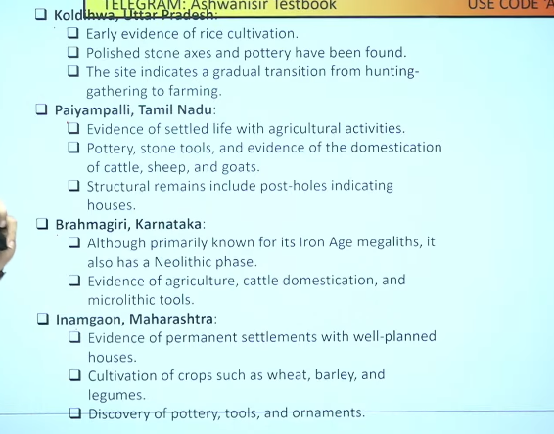

Q.5

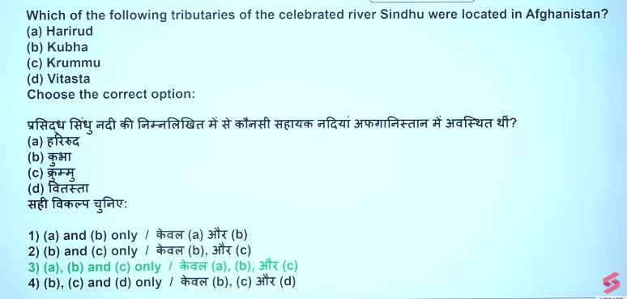
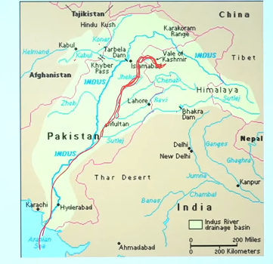
No, the Vitasta (modern-day Jhelum) is not a tributary of the Sindhu (Indus) located in Afghanistan. The Vitasta is a major river of the Kashmir Valley and Punjab region. Sindhu tributaries located in the Afghanistan region during the Rigvedic period include the Kubha (Kabul River) and Krumu (Kurram River).
Key details regarding the location of these rivers:
- Vitasta (Jhelum): Flows through the Kashmir valley and Pakistan, not Afghanistan.
- Kubha (Kabul): Identified as the modern Kabul River, a major right-bank tributary of the Indus flowing through Afghanistan.
- Krumu (Kurram): Associated with the Kurram River, located in the Afghanistan/Pakistan border region.
- Suvastu (Swat): Another tributary listed in the Rigveda that was located in the Afghanistan/Pakistan region.
The Vitasta is considered one of the Sapta Sindhu rivers, but its geographic location is entirely in the Indian subcontinent's northwestern part (Kashmir and Punjab), not in Afghanistan

Yes, the Jhelum River, known in ancient Sanskrit as Vitasta, is a major tributary of the Sindhu (Indus) River that flows through Pakistan.
Key details regarding the Jhelum (Vitasta) River:
- Location: It rises in Jammu and Kashmir (India) and flows into Pakistan, where it merges with the Chenab River, which is part of the Indus river system.
- Name: The river is known as Vitasta in the Vedas, Hydaspes to the ancient Greeks, and Veth in Kashmiri.
- Significance: It is one of the five major rivers of the Punjab region that joins the Indus in Pakistan.
Note: The Vitasta (Jhelum) is often referred to as a tributary of the Chenab within Pakistan before the combined rivers flow into the Indus.

Q.5
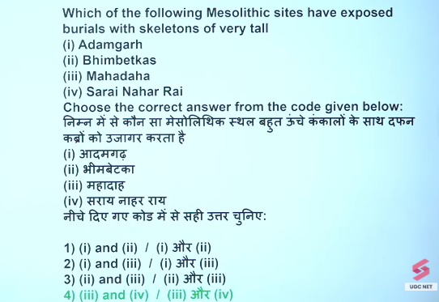

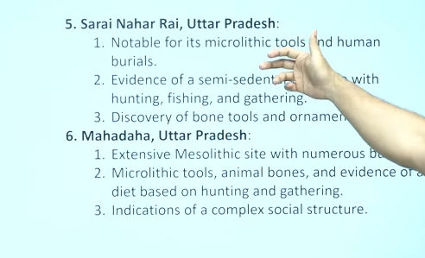
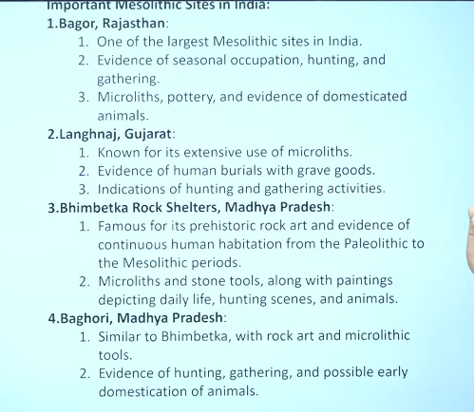
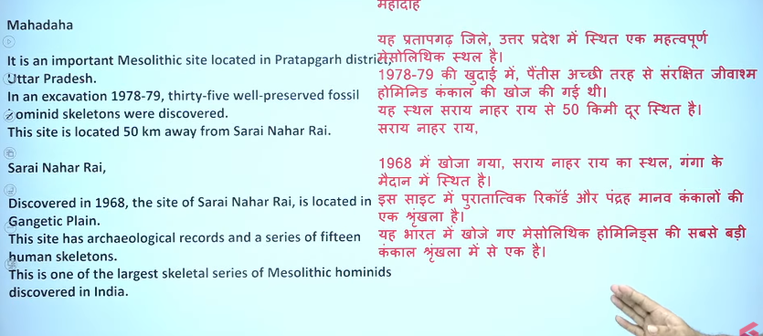

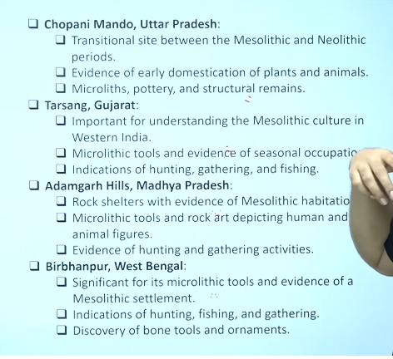

Q.6
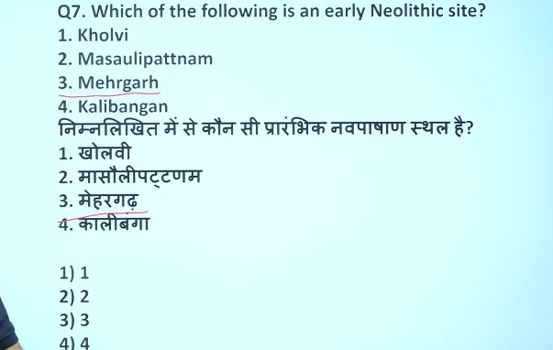
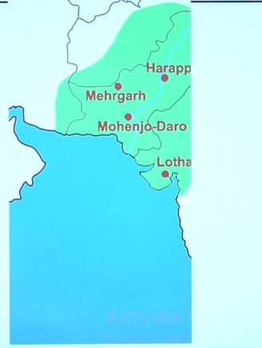

Q.6
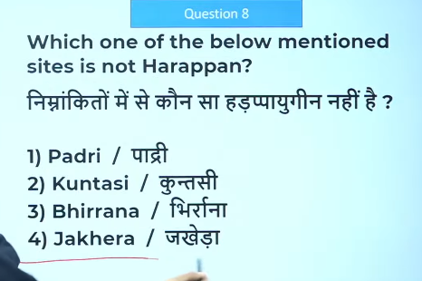
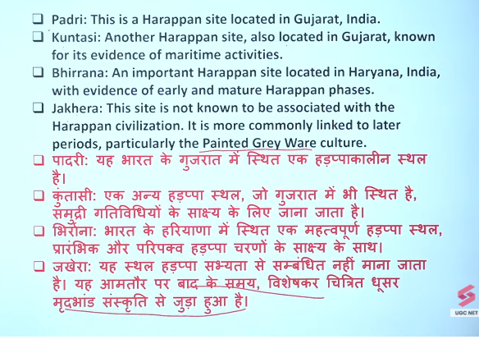

Q.7
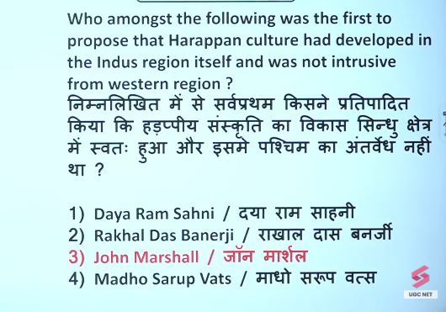
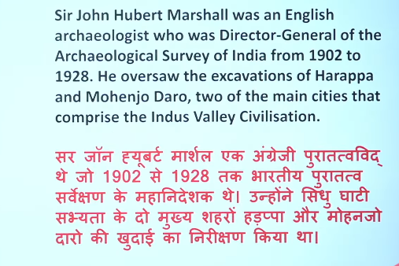

Q.8
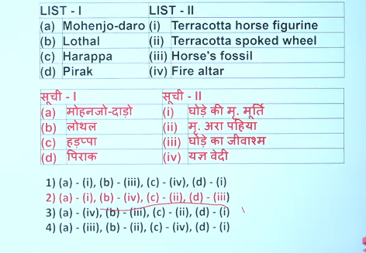

Q.10
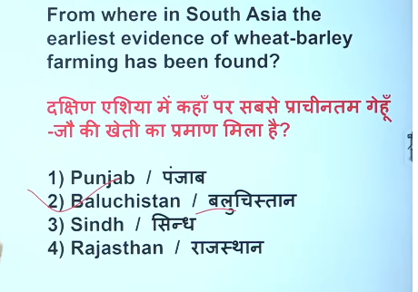
Pakistan Mehrgarh

Q.11
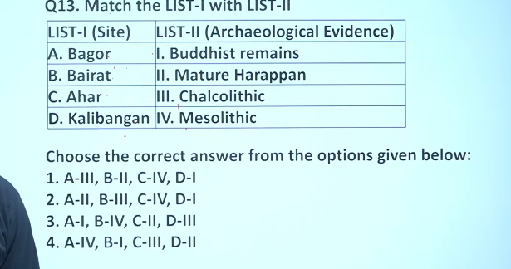

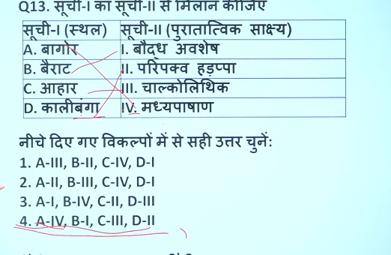

Q.12 Masss production of microliths- Bagor
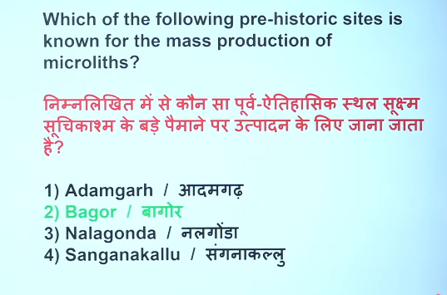
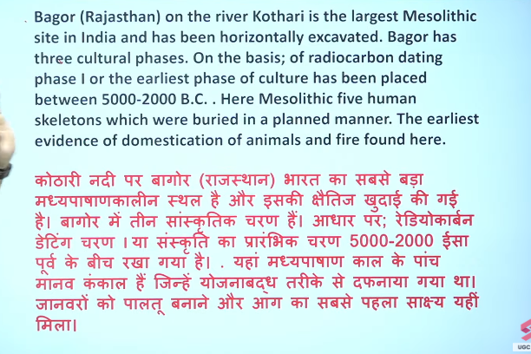

Q.13
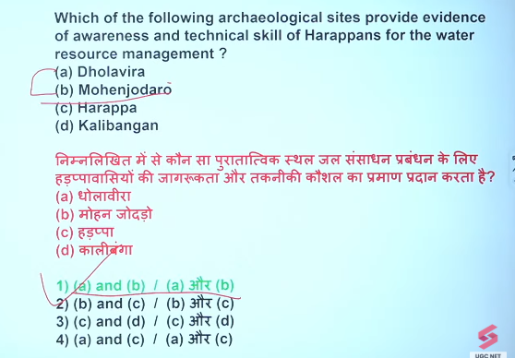

Q.14
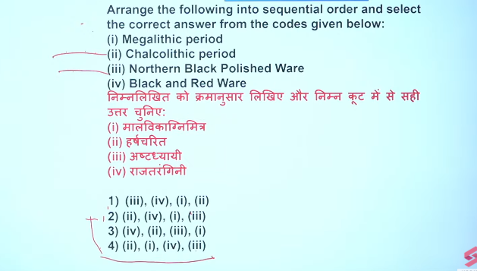

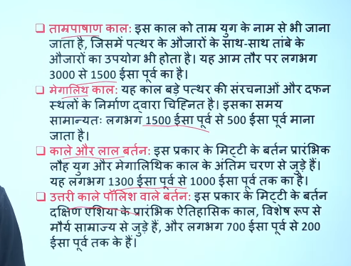
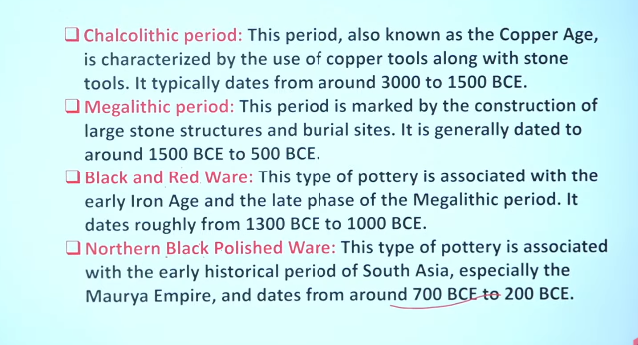

Q.15
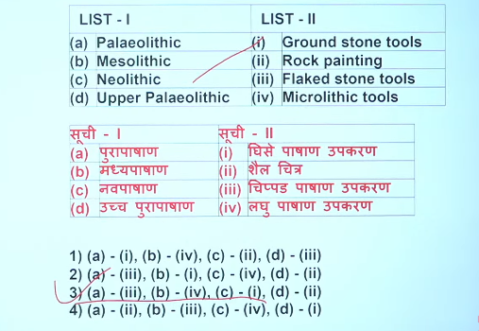

Q.16
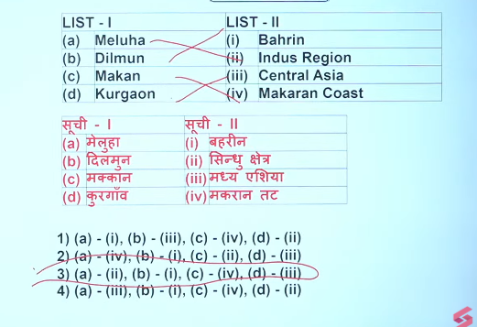

Q.17
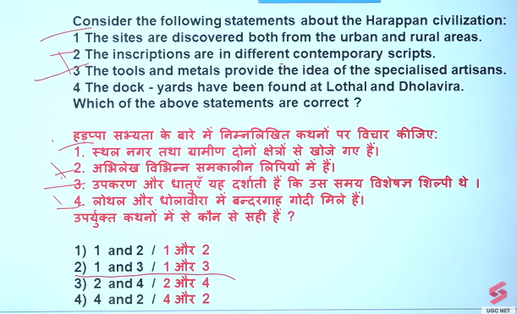

Q.18
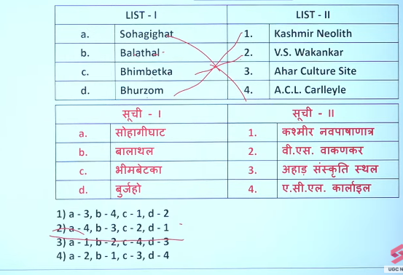

Q.19
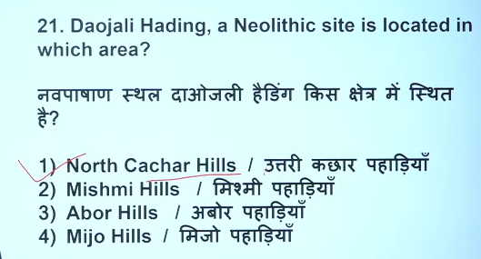

Q.20
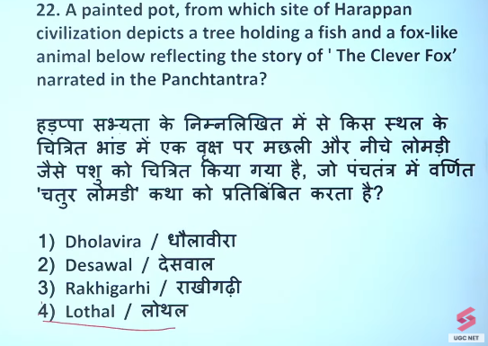

Q.21
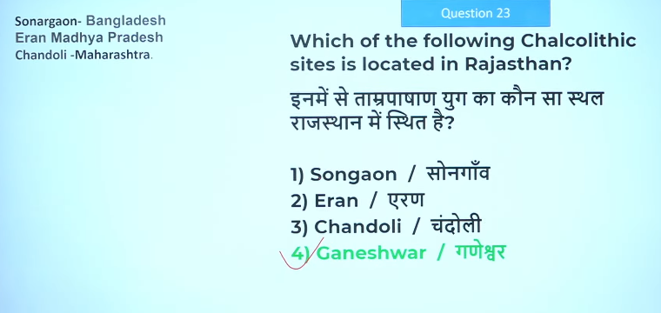

Q.22
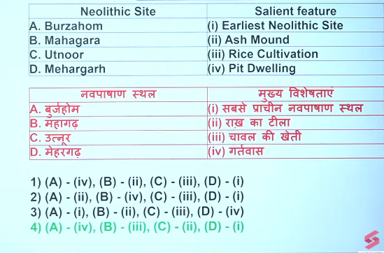

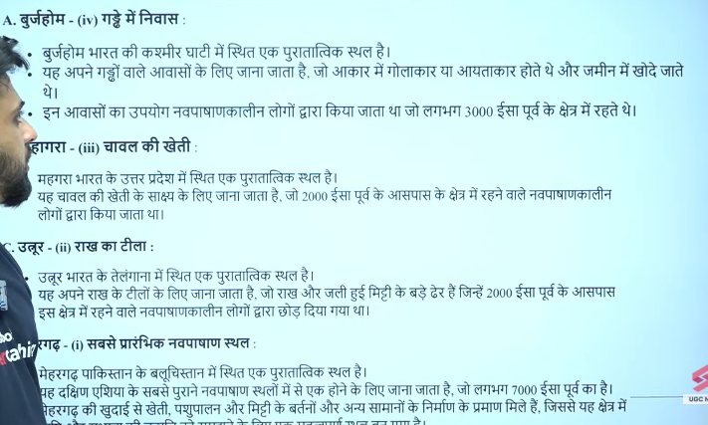

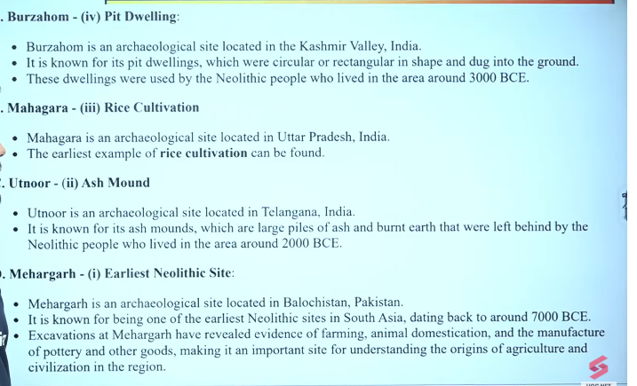

Q.23
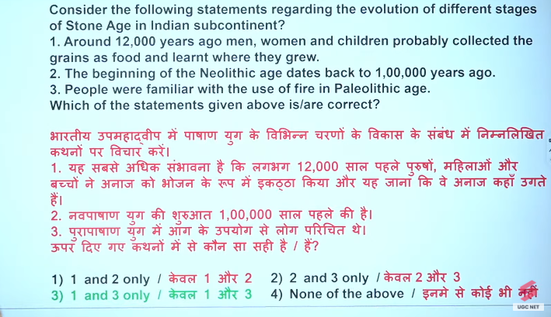
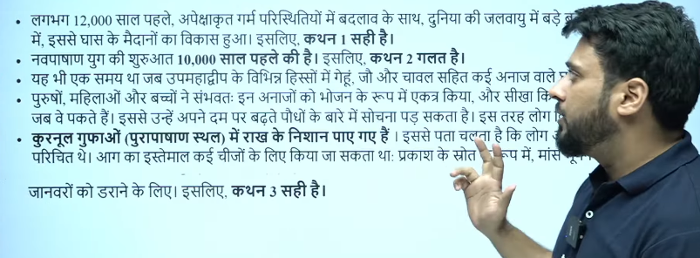

Q.24


Correct answer is 3 not b

25
सिंधु घाटी सभ्यता के प्रमुख शहर मोहनजोदड़ो (Mohenjo-daro) को "मृतकों का टीला" या "मुर्दों का टीला" (Mound of the Dead) कहा जाता है। यह सिंधी भाषा का शब्द है, जिसका शाब्दिक अर्थ मृतकों का ढेर है, क्योंकि खुदाई में यहाँ भारी मात्रा में नरकंकाल और पुरानी बस्तियों के अवशेष मिले थे।
मुख्य बातें:
- अर्थ: मोहनजोदड़ो = मृतकों का टीला।
- स्थान: यह वर्तमान पाकिस्तान के सिंध प्रांत के लरकाना जिले में सिंधु नदी के तट पर स्थित है।
- खोज: 1922 में राखालदास बनर्जी (R.D. Banerji) द्वारा की गई।
- कारण: यहाँ खुदाई के दौरान एक के ऊपर एक कई बस्तियाँ और मानव कंकाल मिले थे, जिससे यह नाम पड़ा।
यह सिंधु घाटी सभ्यता का सबसे बड़ा शहर था। इसके अलावा, गुजरात स्थित हड़प्पा स्थल लोथल को भी कुछ संदर्भों में "मृतकों का टीला" कहा जाता है, जैसा कि इस वर्डप्रेस लेख में वर्णित है

